

**SCHOOL OF PURE AND APPLIED SCIENCES**

**WASTE MANAGEMENT SYSTEM**

**PRESENTED BY:**

**BRIAN NDUNG’U IRUNGU**

PA107/G/7463/19

COMPUTER SYSTEMS ENGINEERING

PROJECT SUPERVISOR:

**MR KIRORI**

A research proposal submitted to the school of Pure and Applied Sciences in partial fulfillment of the requirements for the bestowment of the Bachelor’s degree in Computer Systems Engineering at Kirinyaga University.

**NOVEMBER, 2022**

## DECLARATION

I certify that the study proposal I'm submitting is entirely original to me and hasn't been submitted to another university.

NAME: BRIAN NDUNG’U IRUNGU

Signed ………………… Date………………….

**SUPERVISOR’S DECLARATION**.

I certify that as the university supervisor, I gave my approval for this study proposal to be submitted for review.

NAME: ZACHARY KIRORI

Signed …………………. Date………………

## ACKNOWLEDGEMENT

First, I want to sincerely thank God for giving me this opportunity to undertake this project, and in good health. I would want to sincerely thank my supervisor. as well. Mr. ZACHARY KIRORI who was always there to lead me down the proper route till my project proposal was completed.

I also want to express my gratitude to my parents for helping me out financially throughout the project. My acknowledgments extend to the University for providing abundant resources: lecturers, Computer laboratories just to mention a few, and also fast internet around the school to help in my research.

Last but not least, I'd like to thank my friends and fellow students' presence and assistance during this time. Whenever I requested their assistance, they always showed up.

## ABSTRACT

Software application systems have brought a big transition in the world today. Through the continuous use of software applications, time wastage has been minimized which has led to increased productivity as many organizations use software applications systems to communicate and interact with their clients in any part of the country which has increased efficiency. The waste management system is an application system that will be connecting waste consumers to waste collectors who will be connected to recyclers and refurbishing companies according to the kind of waste one has. With the help of the system, one will be in a position to specify the kind of garbage they have whether plastic, metal or organic and select their waste pickup collection day. This research intends to develop a system that minimizes waste disposal in garbage sites and minimizes environmental pollution caused by burning waste products in garbage sites. The existing manual systems were inefficient as waste is only collected in some parts leaving out the rest whereby the collected waste is later taken to the dumping sites for disposal. Several systems were reviewed starting with the manual systems to understand more about how they work, proving they were inefficient and time-consuming. The web-based systems developed had one common gap: They only collected the waste products they required for recycling leaving out the other waste products.

Contents

DECLARATION i

ACKNOWLEDGEMENT ii

ABSTRACT iii

LIST OF FIGURES vii

CHAPTER ONE: INTRODUCTION 1

1.0 INTRODUCTION 1

1.1 BACKGROUND OF STUDY 1

1.2 EXISTING SYSTEM 2

1.3 STATEMENT OF PROBLEM 2

1.4 PROPOSED SYSTEM 3

1.5 PURPOSE OF STUDY 4

1.6 MAIN OBJECTIVE 4

1.7 SPECIFIC OBJECTIVES 4

1.8 JUSTIFICATION 5

1.9 SCOPE 5

1.10 LIMITATIONS 5

1.11 SIGNIFICANCE OF THE STUDY 5

1.12 OPERATIONAL DEFINITION OF TERMS 6

CHAPTER 2: LITERATURE REVIEW 7

2.1 INTRODUCTION 7

2.2 RELATED LITERATURE REVIEWS 7

2.2.1 Tranbiz waste solutions 7

2.2.2 Bins (Nairobi) services limited 8

2.2.3: Taka Taka Ni Mali solutions 9

2.2.4: Waste Afrika Kenya Limited 10

2.2.5: Kamongo Waste Paper Limited 11

2.2.6: Colnet limited 11

2.2.7: Mason Services Limited 12

2.3 Gaps 13

2.4 Conceptual Framework 14

2.5 Chapter Conclusion 14

CHAPTER 3: SYSTEM DEVELOPMENT METHODOLOGY 15

3.1 Introduction 15

3.2 Development Methodology 15

3.2.1. Planning. 16

3.2.3. Analysis and Design phase. 17

3.2.4. Implementation. 17

3.2.5. Testing. 17

3.2.6. Evaluation. 18

3.2.7. Deployment and Maintenance. 18

3.3. Justification of Methodology. 18

3.4. Data collection. 19

3.4.1. Oral Interview. 20

3.5. Data Analysis. 20

3.6. Chapter Conclusion. 20

CHAPTER FOUR: SYSTEM DESIGN 21

4.0 Introduction 21

4.1 Requirements 21

4.1.1 Hardware requirements 21

4.1.2 Software requirements 22

4.1.3 Functional requirements 22

4.1.4 Non-functional requirements 24

4.2 Context level diagram 25

4.3 Input design 25

4.4 Process design 27

4.4.1 Flowchart 28

4.4.2 Sequence diagram 29

4.4.3 User case diagram 30

4.4.4 Entity relation diagram 30

4.5 Database design- Customer and administration 31

4.6 Output design 33

4.7 Conclusion 34

CHAPTER FIVE: SYSTEM TESTING AND IMPLEMENTATION 35

5.0 Introduction 35

5.1 Unit Testing 35

5.2 Integration Testing 36

5.3 System Testing 37

5.4 Database Testing 37

5.5 Implementation Requirements 39

5.5.0 login module 39

5.5.1 Registration module 40

5.6 Coding Tools 41

5.7 System Home Page or Other Relevant Pages 41

5.8 Chapter Conclusion 41

CHAPTER SIX: CONCLUSION AND RECOMMENDATIONS 43

6.0 Introduction 43

6.1 Conclusion 43

6.2 Recommendations 43

6.3 Future Work 44

REFERENCES 45

APPENDICES. 46

APPENDIX I: Budget. 46

APPENDIX. II: Schedule. 47

# LIST OF FIGURES

Figure 2: 1 Tranbiz waste solution website 7

Figure 2: 2 Bins services limited website 8

Figure 2: 3 Taka Taka ni mali website 9

Figure 2: 4 Waste Afrika Kenya limited website 10

Figure 2: 5 Kamongo waste paper limited website 11

Figure 2: 6 Colnet limited website 12

Figure 2: 7 Mason service limited website 13

Figure 2: 8 Conceptual/context diagram 14

Figure 3: 1 iterative model 16

# CHAPTER ONE: INTRODUCTION

## 1.0 INTRODUCTION

This chapter discusses the historical context of the research, the problem statement, the study's purpose, its aims, its hypothesis, its importance, its scope, and any potential challenges to the investigation.

## 1.1 BACKGROUND OF STUDY

waste management is an essential and crucial requirement through our day-to-day activities in matters concerning our health and environment. With the escalating rules requiring adherence to the international standard for garbage disposal, businesses must use efficient waste management software. Companies using external organizations or firms to take care of their waste products will require the software for keeping their record, invoicing, and for scheduling a collection pickup for their waste. The frequent burning of waste is outdated and imposes a great risk to our lives as the smoke from burning elements causes air pollution and it causes the destruction of the ozone layer. Also, the use of files and manual registers for filling during waste collection is too costly and time-consuming.

In the world, there are a few waste management systems that meet occupational safety and health administration regulations whereby they don’t even meet 40% of the required standards. Most effective waste management programs are based in developed countries only.

In Kenya and Africa at large, few waste management systems are effective and those that are deployed only deal with some part of the waste is only waste to be recycled or the waste to be re-used only thereby leaving the other waste in compost sites or disposal sites. The systems collect waste in certain parts of the country and certain households, leaving some households with no connection or contact details to the waste managers.

## 1.2 EXISTING SYSTEM

The current system used for waste management which is a manual system uses spreadsheets to show a collection of waste has been done waste is only collected in a strictly specified day which is time-consuming and it also leaves out a big number of people with their waste as they don’t have the contact details to the waste collection managers which results to people burning the waste or disposing of it in unwanted sites. This collection system mixes all its waste which makes it difficult to sort it for recycling or re-using the waste products such as plastics which may be used in PET industries, paper which may be recycled in paper industries, or metal that might be used in metal industries. The current system after collecting the waste disposes of the waste in waste disposal sites some are residential sites thereby imposing health risks to the residents. In this system, for your waste to be collected, you have to pay a certain fee. This disadvantages some people who do not have the money during the pickup hour, leading to them being left with waste.

## 1.3 STATEMENT OF PROBLEM

Due to the rapid growth in the human population, there has been an increase in the production of waste which has resulted in the emergence of many dump sites. These sites are associated with several health risks and hazards which include water contamination as some wastes from dump sites are flown to water sources during rainy seasons which causes water contamination, air pollution which is caused by the burning of waste in dump sites which leads to emission of hazardous gases such as carbon monoxide which is harmful to human health. Those living around dumpsites are likely to be infected with gastrointestinal parasites, worms, and organisms from the dump sites. This poorly mismanaged environment will first affect the vulnerable people in society who lack the resources needed to reduce the negative effects of the polluted environment.

Through the manual waste collecting system, a lot of time is wasted waiting for the waste collectors to come to pick up your waste of which they even reschedule the allocated picking time without anyone’s knowledge which leads to a lot of time being wasted in the process.

## 1.4 PROPOSED SYSTEM

The proposed waste management system will be an application system connecting household consumers, manufacturers, and recyclers through it. It will assist companies that handle waste and run transfer stations, landfills, and recycling facilities, as well as those that offer services for collecting commercial, residential, or industrial waste.

This system will ensure waste disposal is minimized through reusing, refurbishing, and recycling existing waste materials and products. Through the application system, households or organizations will be able to log in and set their waste collection date and time and specify which kind of waste is to be picked up whether paper, glass, metal plastic, or organic as consumers will be given different labeled bins for putting a different kind of waste. After specifying the kind of waste product a household or organization has, the system will link the waste consumer to the manufacturers or recyclers where if the waste is plastic the consumer will be linked to a PET recycling industry, paper the consumer will be linked to a recycling paper industry and organic to fertilizer manufacturing industries by the system will for the waste to be collected. Through this, the households with recyclable or refurbished able waste will be paid by the recyclers for their waste products rather than them paying for their waste to be collected. Through this, there will be no time wastage as everything and scheduling will be done via the system whereby specific time and date will be allocated for waste collection.

## 1.5 PURPOSE OF STUDY

It is used to develop a system to provide solutions to problems and hazards caused by waste disposal and mismanagement.

## 1.6 MAIN OBJECTIVE

To develop a system that will help in waste management by connecting waste consumers to waste collectors, manufacturers, and recyclers by ensuring the minimization of waste through recycling, refurbishing, and re-using.

## 1.7 SPECIFIC OBJECTIVES

1. To develop a system that analyses and reduces health risks and diseases caused by waste disposal and mismanagement by ensuring there is the proper collection of waste.
2. To design a system that connects waste consumers to waste collectors.
3. To develop a system that categorizes waste for easier collection and recycling.
4. To design a system that helps in reducing environmental pollution caused by disposal sites by ensuring waste is recycled, reused, or refurbished.

## 1.8 JUSTIFICATION

The suggested system seeks to accomplish the specified goal and offer the following solutions.

1. It will enhance the easy and flexible scheduling of waste collection in organizations and households
2. It will reduce waste disposal and mismanagement by connecting waste consumers to recyclers and manufacturers.

## 1.9 SCOPE

The proposal focuses on developing a platform for managing waste products which will be used in households and organizations to schedule a pickup of their waste products at their preferred date and time. The system will serve as a link between waste consumers and recyclers or manufacturers who will be paying for the required products for either recycling or refurbishing.

## 1.10 LIMITATIONS

The system will only be accessed where the internet is available.

## 1.11 SIGNIFICANCE OF THE STUDY

This project is necessary because it seeks to create a platform that will allow people to save the environment by enhancing proper waste management by connecting waste consumers to waste collectors or recyclers.

The project will also help in generating income by selling useful waste products to companies for refurbishing, re-using, or recycling.

The project will also reduce time wastage caused by the inefficient manual collection system and create a fast and simple system to schedule your waste pickup.

## 1.12 OPERATIONAL DEFINITION OF TERMS

**Waste consumers** – These are the people, organizations, or households that produce waste.

**Recyclers** – These are people or companies that collect and sort rubbish or waste and treat it to produce useful materials that may be used again.

**Manufacturers** – These are people or organizations that make goods for sale.

# CHAPTER 2: LITERATURE REVIEW

## 2.1 INTRODUCTION

Case study for the project is explained in this chapter. It also contains variations on earlier systems that are connected to this system.

## 2.2 RELATED LITERATURE REVIEWS

### 2.2.1 Tranbiz waste solutions

Tranbiz waste solutions is a web-based waste management system that only offers medical, pharmaceutical, and hazardous waste management services.

For your medical waste to be collected by Tranbiz solutions, you make a phone call whereby you schedule the pickup of your waste.

This system does not collect other kinds of waste other than medical waste which leads to the other waste products being disposed of call in pits or dump sites. This system also uses manual spreadsheets to fill in the details after a collection of the waste which is time-consuming. Kamau, S. M. (2020)

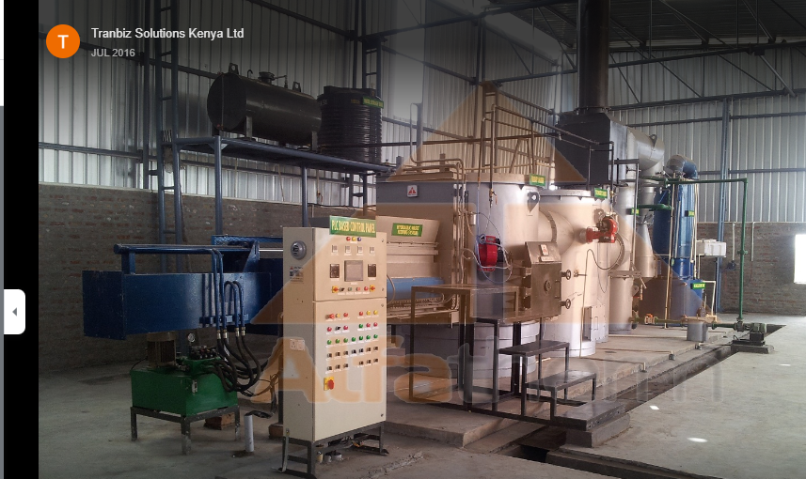

Figure 2: 1 Tranbiz waste solution website

### 2.2.2 Bins (Nairobi) services limited

Bins services limited is a garbage collection and recycling waste management system that offers comprehensive garbage collection services within Nairobi County only. Through their website, you can specify the kind of waste you have and a collection date will be sent to your phone via email. Bins Limited is one of the most efficient waste management systems but it only works around Nairobi County thereby leaving the other parts of Kenya with their waste products. Their system is disadvantageous as they are the ones that set up their collection date which will be inefficient to the consumer as he or she has to put aside whatever he was doing and wait for the collectors. Sometimes websites fail and thus it will be difficult for someone to place his garbage collection request. Ikiara, M. M., Karanja. (2018.

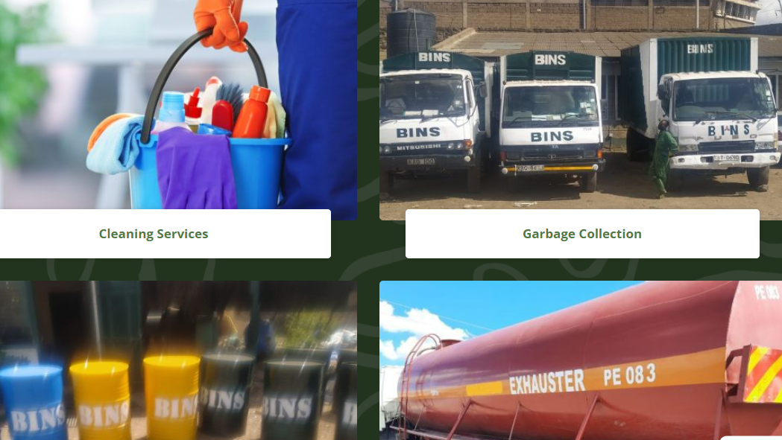

Figure 2: 2 Bins services limited website

### 2.2.3: Taka Taka Ni Mali solutions

It is among the leading waste management companies in Kenya. The company is an application and a web-based system. Through their application, consumers can set up a collection pickup, set up their collection date and time, specify the kind of waste that one has and you can track their collection history in the application. The system is good but there is no way the consumers benefit from the application as the Taka Taka Ni Mali group does their recycling with the waste products collected from the consumers. The system does not link the waste consumers with the recyclers. They benefit from the waste products collected from the consumers. Kerala, P., Low, J. S.(2019)



Figure 2: 3 Taka Taka ni mali website

### 2.2.4: Waste Afrika Kenya Limited

It is a renowned solid trash management company that offers secure and legal waste disposal services. In their asbestos landfill, they improve the secure removal and disposal of asbestos-containing waste. Additionally, the business provides comprehensive solid waste management services, materials recovery, as well as recycling, reuse, source reduction, source separation, and safe handling of hazardous materials. The waste management system is inefficient as it only deals with asbestos and hazardous waste products. Korir, W. K. (2015).

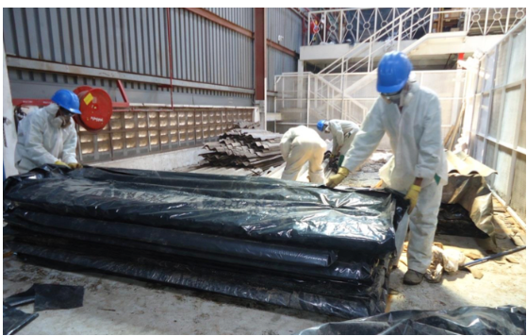

Figure 2: 4 Waste Afrika Kenya Limited website

### 2.2.5: Kamongo Waste Paper Limited

It is a waste management system that deals with the collection of paper waste products which are later taken for recycling.

The Kamongo waste paper limited is a web-based system where if you have any paper or any paper-related waste products you contact them through their website and a pickup collection date is allocated. The system only deals with paper waste products thus leaving out people with other types of waste products such as plastic and organic waste. They are only located in Mombasa Eldoret and Nakuru which makes it difficult to reach them if you are not in the stated regions.

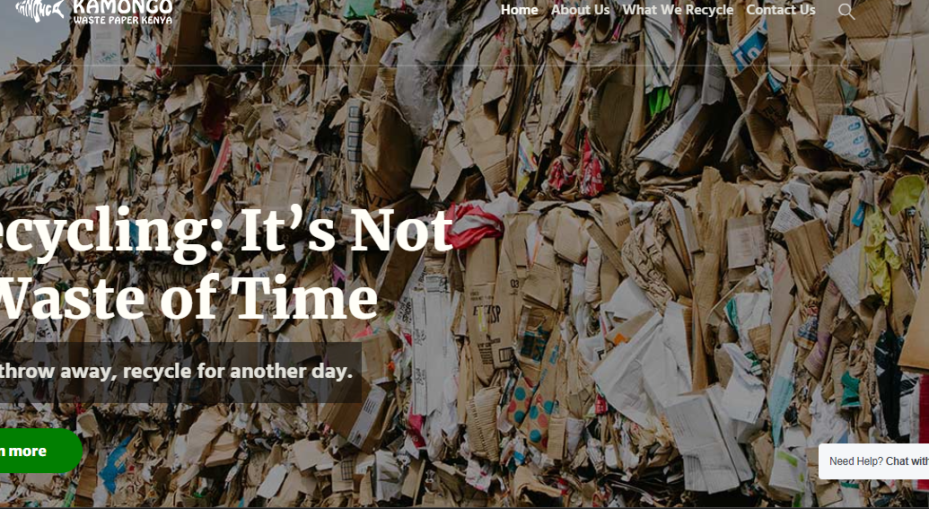

Figure 2: 5 Kamongo waste paper limited website

### 2.2.6: Colnet limited

It is a web-based waste management system that offers garbage collection services, cleaning services, sanitary disposal, and ground maintenance services. They offer a full range of containers to suit consumers’ waste production and enhance ease of collection as waste will be separated in the bins given. Their containers are well labeled where if it is plastic waste, you put your waste in the plastic container, organic you put your waste in organic containers, and paper in the paper containers. The system does not link consumers with recyclers. The company later takes the waste to its preferred recyclers and sells the required products such as paper products. Bell, D. L. (2020).

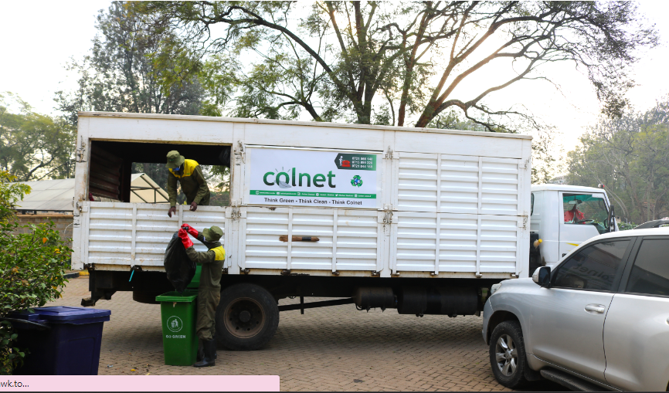

Figure 2: 6 Colnet limited website

### 2.2.7: Mason Services Limited

It is a company with a web-based waste management system that collects and disposes of any of your construction waste in an environmentally safe manner, often by recycling it. Drop off items such as office waste, scrap wood, and engine parts after collection are refurbished or recycled. Organizations or households place their waste collection order via Mason’s website. You have to pay a collection fee for your waste to be collected it does not matter which type of waste is it or whether it can be refurbished or recycled. The consumers do not benefit or gain anything from their recyclable items which are sold to recycling organizations. Kang, H. Y., & Schoenung, J. M. (2016)



Figure 2: 7 Mason service limited website

## 2.3 Gaps

From the reviews of the above systems, we can say that most of the operational systems are manual and are not effective enough. First, there are so many forms to fill which leads to errors since a human being is the one filling the form, forms can be lost and damaged easily, and filling the form is time-consuming.

Most of the systems listed above only deal with a specific type of waste products that they can recycle or refurbish thereby leaving the other kinds of waste to be disposed of anywhere or burnt.

The above systems are costly as they charge the consumers a collection fee for their waste. The systems are the ones that set up the garbage collection and pickup time which should be set up by the consumers in their free time to avoid time wastage. In the above systems, consumers do not benefit from their useful waste products that are recycled or refurbished.

The proposed system will integrate all this and ensure waste is managed properly and every consumer earns from the useful waste products he or she has given to the recyclers or manufacturers.

## 2.4 Conceptual Framework

This is where the interaction between users and the system itself is briefly outlined.

Household/ consumer

Waste is picked up at a

The commodity is household/organization

Bought by consumer

Commodity market

Transport of waste products

Government verifies waste is transported Products and sends for recycling them to market

Government verification

Recycling/ refurbishing plant

recycles/refurbishes

products and sends them for verification

Figure 2: 8 Conceptual/context diagram

## 2.5 Chapter Conclusion

A waste management system is required to manage waste products effectively and without wasting time.

# CHAPTER 3: SYSTEM DEVELOPMENT METHODOLOGY

## 3.1 Introduction

The system's development process is described here. The methods used to collect data for the system are also covered in this chapter, accompanied by a justification for the developer's choice to make use of this approach.

## 3.2 Development Methodology

This is the division of the software development process into phases and activities allows for better management and planning. The study used an iterative methodology. Instead of spreading out the entire project throughout the software development phases, each step is divided into smaller projects that might grow in importance as the final product develops. The phases would be gradually integrated into the model to create an entire software development process.

The requirements will be addressed first in the iterative model making it appropriate for the system. Requirements that emerge later will be added gradually and in tiny bits hence the model's name. Also, each product iteration released is of a working system, and the customer will get the necessary functionality earlier while still interacting with the system one on one. Furthermore, testing the small iteration is more manageable than testing the fully integrated system.

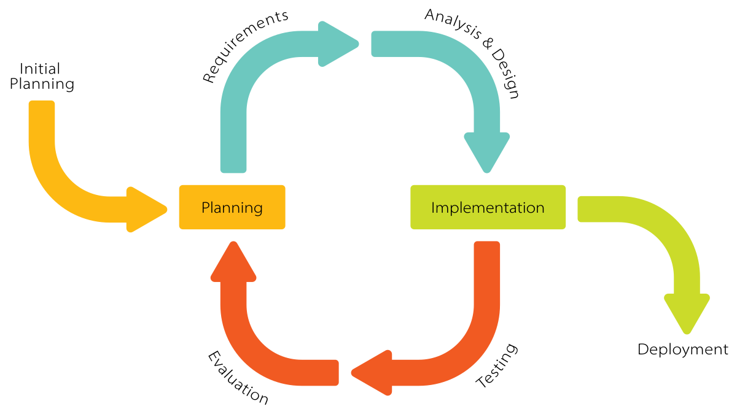

Figure 3: 1 iterative model

### 3.2.1. Planning.

In this phase, the developer will go through the initial steps of planning. The specification documents will be mapped out and preparations for the upcoming stages of the cycle will be done here. This will be accomplished by using a Gant Chart to divide the entire development process into manageable chunks. The Gant Chart will help the researcher understand when a task starts and how long it lasts. A Work Breakdown Structure would also be used in breaking down key tasks into more manageable activities, this will greatly assist in budget planning.

##### 3.2.2. Requirement phase.

Consumer requirements will be obtained during this phase, and an analyst will check them to make sure they meet the requirements. The Analyst will check whether the project’s needs will be achieved within budget or not. All possible requirements will be documented in the software requirement specification document. A review of similar systems but in different organizations will be done to get to know more about what the system we are developing will require and how it will operate. A review of previous documents would be done to see how these similar systems used to operate in line with the system being developed.

### 3.2.3. Analysis and Design phase.

The team will create the software using a variety of diagrams during the design phase, including Data Flow Diagrams, Activity Diagrams, Class Diagrams, State Transition Diagrams, and Universal Modeling Languages. The developer will prepare a design of the system he intended to come up with by mapping these requirements to a system model. This phase will help in defining the hardware and software requirements needed. The developer will design the schematics that explain the software's behavior, business process, interface design, and system functioning.

### 3.2.4. Implementation.

In the implementation phase, requirements will be designed in a programming language and transformed into the software. The developer will develop the system in form of an interactive interface. This will be achieved by using the JAVA programming language to design the application. MYSQL server will be applied to create and manipulate the database where information will be stored and accessed on demand.

### 3.2.5. Testing.

After the programming phase is done, testing will be done to identify potential issues and bugs with the software. This stage will involve Unit Testing where individual phases developed in the implementation stages will be tested separately to determine whether any issues emerge and also to discover debugging defects to correct flaws and errors that will be discovered. The developer will then use integration testing where software modules will be integrated logically and tested as a group. The registration interface will be integrated with the admin system to view how both relate

### 3.2.6. Evaluation.

Once all prior stages are complete, a thorough evaluation of the system will be done whereby the entire team, clients, or other outside parties will examine whether the requirements have been met and it is fit for purpose. The requirements initially specified will be reviewed against the system and determine whether the system satisfies these criteria. The functionality of the product and how it reacts to user needs will validate whether the software is appropriate for the task at hand. Evaluation will prove that the software will be:

Reliable – does it give the desired output?

Efficient – saves on time, storage and cost.

Portable – will it be transferred from one platform to another?

Robustness – work correctly and handle user errors and Maintainability.

### 3.2.7. Deployment and Maintenance.

The system will be made available to the customer's environment after unit testing. This will be done through Parallel deployment where old and new systems are used simultaneously to see how the users will adjust to the changes. Maintenance will be carried out in response to ongoing user feedback. Due to the incremental and cyclical nature of the technique, updates and patches will be handled with ease. The developer will be required to review the system after 5 months and check the issues that will have been raised and see if the system is used according to its purpose.

## 3.3. Justification of Methodology.

The methodology stated above is highly recommended because of the following:

1. Rapid Turnaround: The benefit of an iterative process is that each stage can be effectively condensed into ever-tinier periods, depending on what is required to meet the goals of the project.

2. Easy to adapt: Another key benefit of the iterative model is its capacity to swiftly adjust to the constantly changing needs of the project and the whims of the client, building on the fundamental strength of constant, numerous revisions that come out regularly.

3. Each cycle is easily controllable and each iteration includes risk identification and mitigation.

4. Less costly to change the scope or requirements.

## 3.4. Data collection.

Data required for the project was obtained during project research from a variety of sources. The following are the two main techniques used in this study to gather the data and information needed for the system analysis:

a. Primary source:

It is the method the researcher used to collect original data, which included the use of empirical techniques including in-person visits and verbal interviews.

b. Secondary source:

The researcher used library resources and internet downloads to get the secondary data. The literature review in chapter two discussed the information gathered using these methods.

### 3.4.1. Oral Interview.

This was done between the researcher and different members of households and organizations. Additionally, several department heads were interviewed, and the researcher's inquiries to the employees of the various organizations yielded trustworthy information.

## 3.5. Data Analysis.

The results of the fieldwork were examined, and the researcher utilized inferential analysis, in which a sample of the total data was analyzed. Different conclusions were drawn from the data by choosing various samples. The researcher found out that all the systems had the same gap.

## 3.6. Chapter Conclusion.

When creating computer system projects, understanding the software development life cycle is crucial. To effectively meet their needs, the researchers have the freedom to select the development approach they want to use following the kind of system they are designing.

# CHAPTER FOUR: SYSTEM DESIGN

## 4.0 Introduction

This chapter highlights the requirements used to come up with the entire system. It contains requirements, context level diagram, input design, output design, database design for the waste consumer and administration, and process design which contains diagrams such as flowcharts, sequence, activity, use case, and editing relation diagram. Entities involved are also included.

## 4.1 Requirements

Requirement analysis and specification are concerned with the identification of the basic function of the software component. It relates to getting the requirements and the various specifications, which are required for developing particular software. For the waste management system to be used efficiently, all computers and laptops need certain hardware components or other software resources to be available. Otherwise, the system will not generate the desired output or it may not work at all. The software and hardware requirements for this system have been discussed below;

### 4.1.1 Hardware requirements

Consists of the hardware requirements that must be met when coming up with the proposed system. The following are required for better functioning of the web-based application:

Desktop computer

To be used for the design and development of the system. It should have the following specifications:

* A memory of 4 GB RAM or more
* 1 GB (or more) available hard disk space
* Flash disk (8 GB)- will be used as a backup for the documentation of the project
* Processor 1.8 GHZ processor speed
* RAM 512MB
* An enhanced keyboard.
* A power stabilizer.

### 4.1.2 Software requirements

Many software requirements must be met for the Nakumatt supermarket management system to run successfully.

* Operating system: Windows 8 or higher versions of OS (Windows 10 Pro)- this will act as a link between the hardware and software programs.
* XAMPP server 3.2.4 will be used as a local web server and a database to store details of the system.
* Programming languages: JAVA, MYSQL database

### 4.1.3 Functional requirements

These are the main functions and capabilities of the system that must be performed successfully.

1. **Register account**

All members of a system must be able to create an account by filling in the required account details that include their username, email, and password that will be used to access the system

1. **Log in**

Upon providing the Email and password all members will be able to log in.

1. **Add service**

Admin will have the ability to add, view, and edit details in the database.

1. **Consumer details and edit profile**

The system will allow the consumer to alter their details like changing their telephone number, email and username.

1. **Make a waste pickup request and receive an email notification**

The system will allow consumers to put up a waste collection request and can track his or her collection in the application.

Other functionalities that were expected to perform by the system are:

1. The system should allow users to change passwords for security purposes
2. The system should allow users to record all information about waste collection, the time to be collected, the type of waste and the consumer’s address.

### 4.1.4 Non-functional requirements

These are the requirements that supplement the main function and capabilities of the system.

1. **Usability-** the system should be user-friendly with interfaces that are easy to use.
2. **Security-** only authorized users should be allowed to access the system.
3. **Reliability and availability-** the system should be reliable and available to all customers of the supermarket at all times.
4. **The integrity-**the system should ensure that the system’s data is not corrupted.
5. **The performance-**the system should have an acceptable response time when performing its functions.

## 4.2 Context level diagram

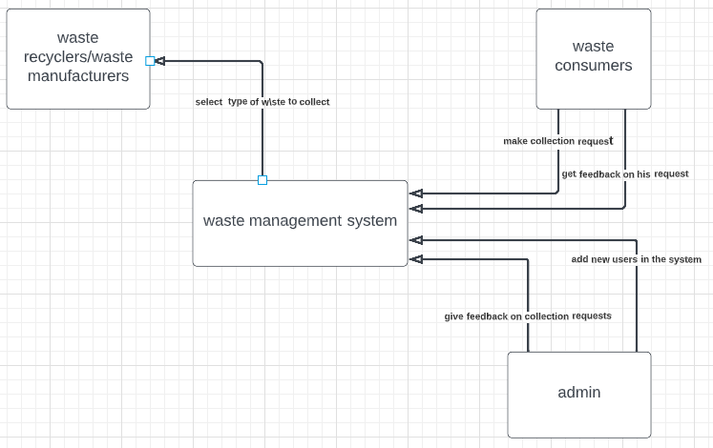

## 4.3 Input design

In any organization, institution, or system of operation, there is always an input into the system which keeps the system running. Wrong input results in wrong output.

|  |
| --- |
| **CONSUMER REGISTRATION FORM**  **USERNAME**  **EMAIL**    **PASSWORD**  **SUBMIT** |

**Form:** 4.1 add members form

The above form shows the details required to add a new member.

|  |
| --- |
| **USER LOG IN**  **EMAIL**    **PASSWORD**  **SUBMIT** |

The above form shows details captured when a customer or user is logging in to the system.

ADMIN LOGIN INPUT

Email

Password

**LOG IN**

**form:** 4.4 admin login

The above table shows the admin's details captured when accessing the system.

## 4.4 Process design

The researcher showed the use of process design tools such as program flowchart diagrams, sequence diagrams, activity diagrams, use case diagrams, entity relationship diagrams, and context diagrams that were used to represent all the processes in the system.

### 4.4.1 Flowchart

The figure below shows the flowchart of all systems.

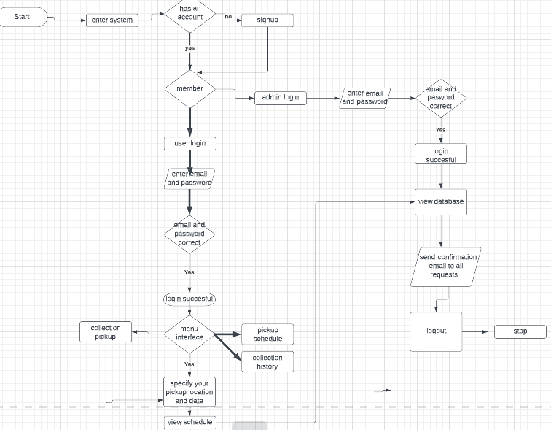

### 4.4.2 Sequence diagram

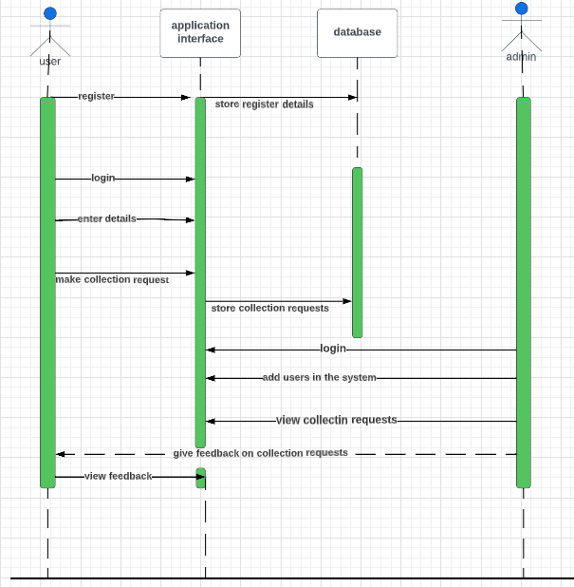

### 4.4.3 User case diagram

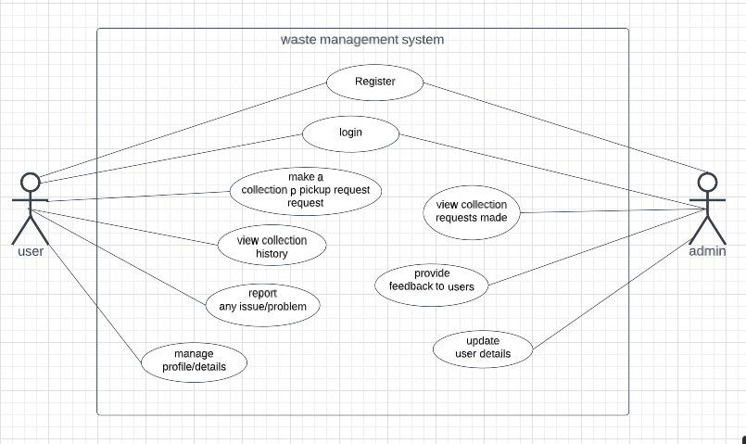

### 4.4.4 Entity relation diagram

The ERD below illustrates all the entities with their relations and associated attributes to make up the Waste Management System.

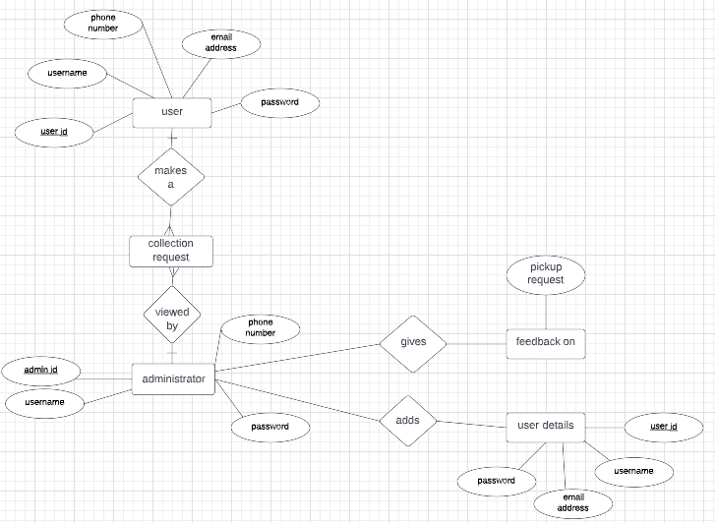

## 4.5 Database design- Customer and administration

A database is a file composed of records, each containing fields together with a set of operations it helps in organizing data in a logical order for references. Database design is the process of producing a detailed data model of a database and for us to come up with the best database model.

The database contains related data which are organized together in a group of object, table, and file it can be informed of a node. In this project, a relational database concept was used in this appraisal, and related data was stored or organized in a different table. The database design of this system is as shown:

**Registration table**

|  |  |  |  |  |
| --- | --- | --- | --- | --- |
| NAME | DATA TYPE | LENGTH | KEY | DEFAULT VALUE |
| Reg Id No | Int | 10 | Primary key | Not null |
| username | Varchar | 45 | Foreign key | Not Null |
| email | Varchar | 45 | Foreign key | Not Null |

The table above shows the rows and columns of attributes in the user database. The registration id number is the primary key the rest are foreign keys.

**Administrator Table**

|  |  |  |  |  |
| --- | --- | --- | --- | --- |
| NAME | DATA TYPE | LENGTH | KEY | DEFAULT VALUE |
| Id No | Int | 10 | Primary key | Not null |
| Email | Varchar | 15 | Foreign key | Null |
| Password | Varchar | 15 | Foreign key | Null |

The above table shows the rows and columns of an admins database

**User Login table**

|  |  |  |  |  |
| --- | --- | --- | --- | --- |
| NAME | DATA TYPE | LENGTH | KEY | DEFAULT VALUE |
| Id | Int | 10 | Primary key | Not null |
| Username | Varchar | 45 | Foreign key | Not Null |
| Password | Varchar | 45 | Foreign key | Not Null |
| Admin | Int | 30 | Foreign key | Not Null |

**Pickup location table**

|  |  |  |  |  |
| --- | --- | --- | --- | --- |
| NAME | DATA TYPE | LENGTH | KEY | DEFAULT VALUE |
| Id | Int | 10 | Primary key | Not null |
| Location | Varchar | 45 | Foreign key | Not Null |
| Address | Int | 45 | Foreign key | Not Null |
| Phone number | Int | 45 | Foreign key | Not Null |
| Pickup date | Int | 45 | Foreign key | Not Null |
| Pickup time | Int | 20 | Foreign key | Not Null |
| Waste type | Varchar | 30 | Foreign key | Not Null |

## 4.6 Output design

**Waste pickup report**

|  |  |  |  |  |
| --- | --- | --- | --- | --- |
| **Id** | **Waste type** | **Collection date** | **Pickup time** | **Pickup address** |
|  |  |  |  |  |
|  |  |  |  |  |

**Consumer report**

|  |  |  |  |  |  |  |
| --- | --- | --- | --- | --- | --- | --- |
| **Id** | **Name** | **Date** | **Waste type** | **address** | **location** | **Phone number** |
|  |  |  |  |  |  |  |
|  |  |  |  |  |  |  |

## 4.7 Conclusion

This Chapter has specified the design of the Waste Management System. The aspects of the design that have been discussed are system design, process design, interface design, and database design by providing the context diagram, sequence diagram, use case diagram, activity diagram, flowchart, and ERD.The various designs ranging from the input design to the output design ensure the timely completion of the implementation process.

# CHAPTER FIVE: SYSTEM TESTING AND IMPLEMENTATION

## 5.0 Introduction

This chapter focuses on the testing and implementation phase, which is essential to ensure the application's reliability, functionality, and performance. The testing phase involves various types of tests, such as unit testing, integration testing, system testing, and database testing, to ensure the application meets the functional and non-functional requirements.

## 5.1 Unit Testing

Unit testing is a type of testing that focuses on testing individual units or components of the application. In our waste management application, we conducted unit testing for each module of the application to ensure that they are working as intended. We used JUnit, a popular testing framework for Java, to conduct unit tests. The unit tests helped us to identify and fix any bugs or issues in the application's code.

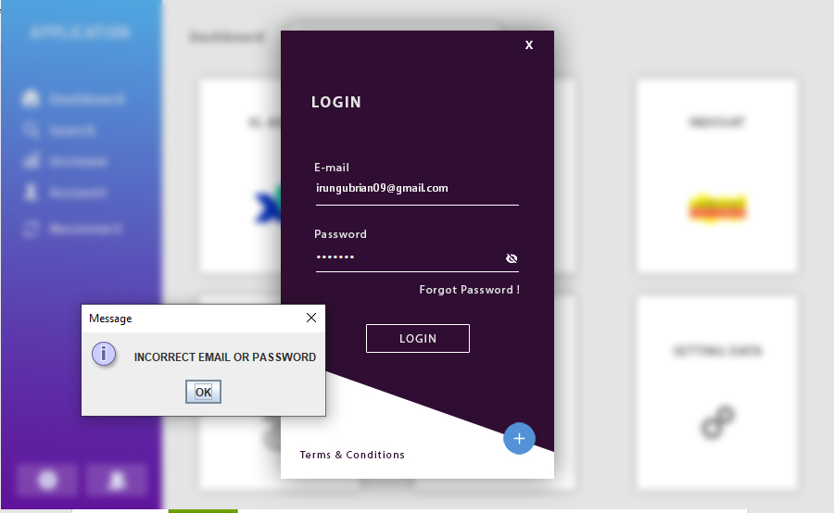

In case an incorrect password or email is submitted an error message “ incorrect email or password” is displayed as shown in figure above.

## 5.2 Integration Testing

Integration testing is a type of testing that tests the interaction between different modules or components of the application. In our waste management application, we conducted integration testing to ensure that all the modules are working together seamlessly. We used TestNG, a testing framework for Java, to conduct integration tests. The integration tests helped us to identify and fix any issues related to the interaction between different modules of the application. They were integrated well to produce desired outputs.

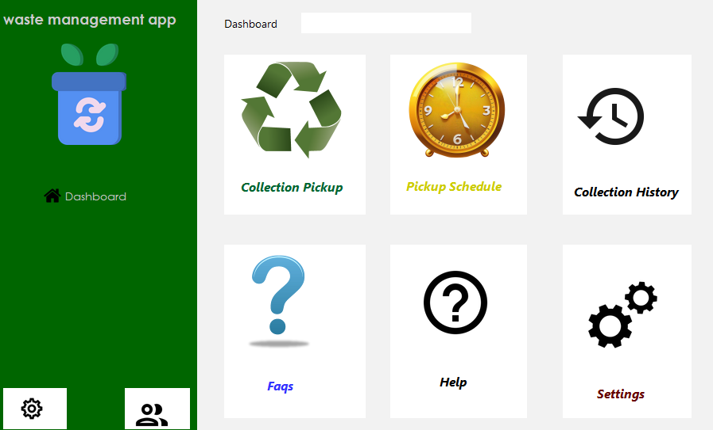

The figure shows the dashboard

## 5.3 System Testing

System testing is a type of testing that tests the entire system or application as a whole. In our waste management application, we conducted system testing to ensure that the application meets all the functional and non-functional requirements. We used Selenium, a popular testing tool for web applications, to conduct system tests. The system tests helped us to identify and fix any issues related to the application's functionality, usability, and performance.

## 5.4 Database Testing

In our waste management application, we conducted database testing to ensure that the application can retrieve and store data correctly. We used DBUnit, a popular testing framework for databases, to conduct database tests. The developer conducted a software test of the schema, tables, and triggers of the database to check its responsiveness, integrity, and consistency of the data.

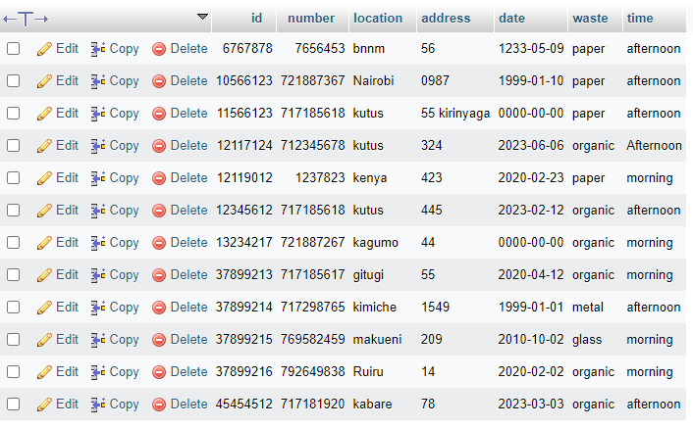

**Editing testing**

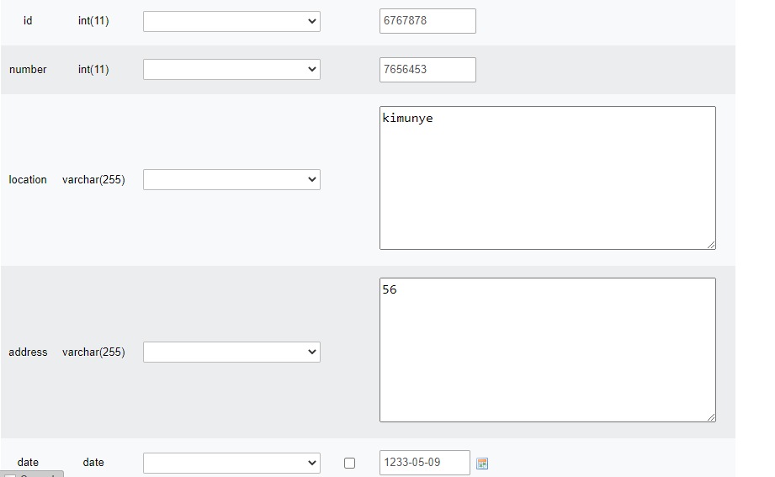

**Delete testing**

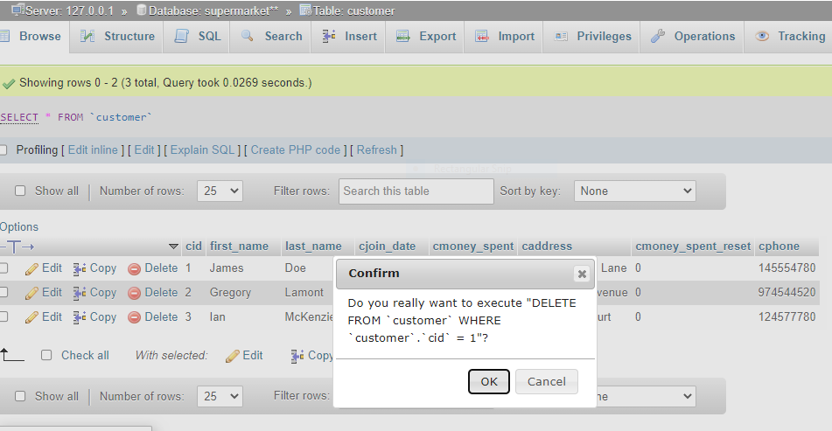

**Inserting testing**

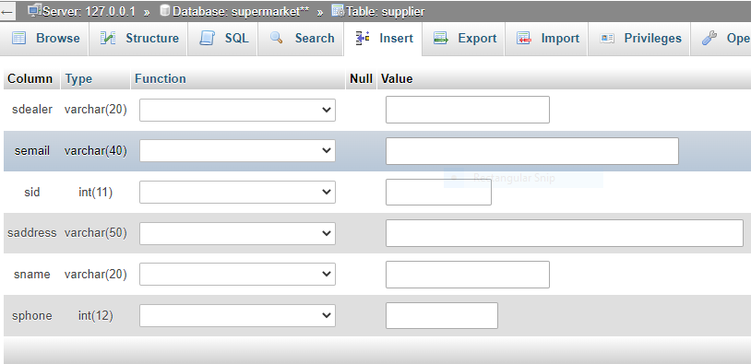

## 5.5 Implementation Requirements

To implement the waste management application, we needed the following requirements:

1. A web server to host the application.
2. A database management system to store and retrieve data.
3. An IDE (Integrated Development Environment) to develop and test the application.
4. A version control system to manage the application's source code.

### 5.5.0 login module

The login module was designed as a gateway for the systems admin and the members of the supermarket to log into the system. They are required to submit their email and their password to access their dashboard. Figure 5.1 shows the form capturing the credentials

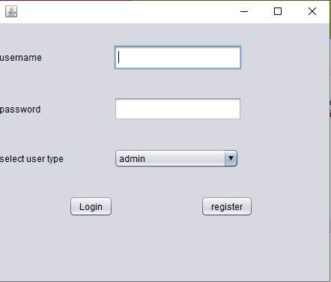

### 5.5.1 Registration module

Developing a system that registers new members was the first objective of the system. This was achieved by developing and implementing a module on the admin's side that captures members' details i.e., username, email, and password.

Figure 5.2 shows the member registration page.

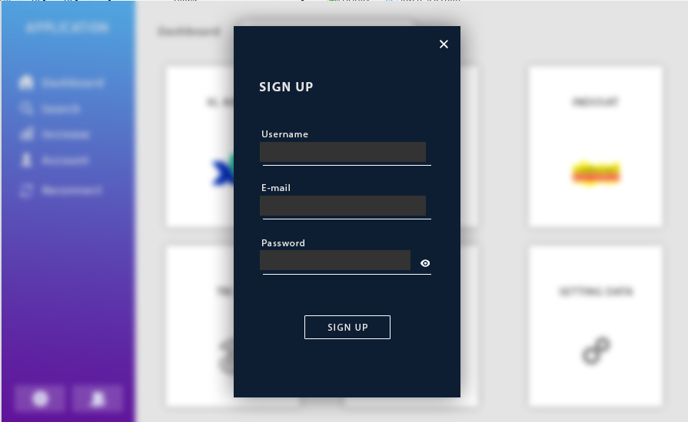

## 5.6 Coding Tools

To develop the waste management application, we used the following coding tools:

1. Java programming language.
2. Spring Framework to develop the application.
3. MYSQL to manage the application's database.
4. PHP to connect the application to the database.
5. Bootstrap Framework to design the user interface.
6. Git version control system to manage the application's source code.

## 5.7 System Home Page or Other Relevant Pages

The waste management application's home page provides the user with options to perform various functions, such as registering a new user, logging in to the system, and accessing the application's features. The application's relevant pages include the user dashboard, where the user can view and manage their waste collection requests and the admin dashboard, where the admin can manage the user's requests.

## 5.8 Chapter Conclusion

In conclusion, the testing and implementation phase of the waste management application is crucial to ensure the application's reliability, functionality, and performance. We conducted various types of tests, such as unit testing, integration testing, system testing, and database testing, to ensure that the application meets all the functional and non-functional requirements. We also identified and fixed any issues related to the application's code and database. The implementation requirements include a web server, a database management system, an IDE, a version control system.

# CHAPTER SIX: CONCLUSION AND RECOMMENDATIONS

## 6.0 Introduction

The waste management application aims to provide an efficient and user-friendly platform for waste management. The application allows users to request waste collection services, track their requests, and manage their waste disposal in an eco-friendly manner. This chapter discusses the conclusion and recommendations based on the waste management application's development and testing.

## 6.1 Conclusion

The waste management application is an effective tool for managing waste disposal services. The application's development and testing phases have been completed successfully, ensuring that the application meets all functional and non-functional requirements. The application's user interface is user-friendly, allowing users to perform various functions with ease. The application's functionality and performance have been tested, ensuring that the application is reliable and efficient.

## 6.2 Recommendations

Based on the development and testing of the waste management application, the following recommendations can be made:

1. Expand the application's reach: The application can be expanded to cover a broader geographical area to cater to more users.
2. Integrate payment gateway: Integrating a payment gateway will enable users to make payments for waste collection services.
3. Improve the search function: The application's search function can be improved to allow users to find specific waste disposal services quickly.
4. Incorporate a feedback system: A feedback system can be incorporated into the application to enable users to provide feedback on the waste disposal services they receive.

## 6.3 Future Work

There are several areas of the waste management application that can be improved in the future, including:

1. Enhancing the application's security features to ensure that user data is protected.
2. Developing a mobile application to make the application more accessible and user-friendly.
3. Integrating social media platforms to enable users to share their waste disposal activities and promote eco-friendliness.
4. Developing a system that enables users to recycle their waste and get rewarded for doing so.

# REFERENCES

Kang, H. Y., & Schoenung, J. M. (2016). Electronic waste recycling: Resources, Conservation and Recycling, 45(4), 368-400.

Ikiara, M. M., Karanja, A. M., & Davies, T. C. (2018). Collection, transportation, and disposal of urban solid waste in Nairobi (pp. 61-91). Springer, Dordrecht.

Kamau, S. M. (2020). Strategic factors influencing effective management of e-waste among waste management firms in Nairobi County (Doctoral dissertation, Strathmore University).

Kerdlap, P., Low, J. S. C., & Ramakrishna, S. (2019). Zero waste manufacturing: Resources, conservation, and recycling, 151, 104438.

Korir, W. K. (2015). Environmental crime management in Kenya (Doctoral dissertation).

Bell, D. L. (2020). Implementation and evaluation of an educational program in low-waste yard maintenance and landscaping techniques (Master's thesis).

# APPENDICES.

## APPENDIX I: Budget.

**Table 4.1:** Budget

|  |  |  |
| --- | --- | --- |
|  | **EQUIPMENT** | **COST** |
| **1** | LAPTOP | 32,000 |
| **2** | TRAVELLING EXPENSE | 5,000 |
| **3** | INTERNET | 4,000 |
| **4** | PRINTING EXPENSE | 2,000 |
| **5** | SOFTWARE EXPENSE | 2,000 |
| **6** | LABOUR | 5,000 |
|  | **TOTAL** | **50,000** |

## APPENDIX. II: Schedule.

